III B Gliaca di Piraino
Lingua Inglese
Prof. Margherita Sirna
Ciao ragazzi! Oggi durante la video lezione spiegherò Charles Dickens, per continuare il nostro studio della letteratura inglese.

Charles Dickens
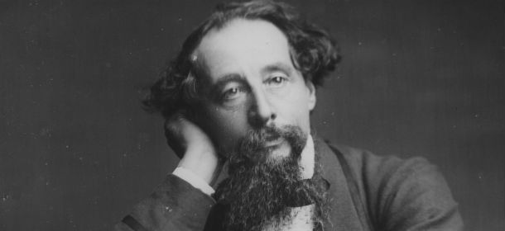
Charles John Huffam Dickens (7 February 1812 – 9 June 1870) was an English writer and social critic. He is regarded as the greatest novelist of the Victorian era. His works enjoyed unprecedented popularity during his lifetime, and by the 20th century, critics and scholars had recognised him as a literary genius. His novels and short stories are still read today.
Born in Portsmouth, Dickens left school to work in a factory when his father was incarcerated in a debtors (debitori) prison. Despite his lack of formal education, he edited a weekly journal for 20 years, wrote 15 novels, five novellas, hundreds of short stories and non-fiction articles, was an indefatigable letter writer, and campaigned vigorously for children's rights, education, and other social reforms.
Dickens's literary success began with the 1836 serial publication of The Pickwick Papers. Within a few years he had become an international literary celebrity, famous for his humour, satire, and keen (acuta) observation of character and society.
The installment format (il format a puntate) allowed Dickens to evaluate his audience's reaction, and he often modified his plot and character development based on such feedback. His plots were carefully constructed, and he often wove elements from topical (attuali) events into his narratives.
His 1843 novella “A Christmas Carol” (Canto di Natale) remains especially popular and continues to inspire adaptations in every artistic genre. Oliver Twist and Great Expectations are also frequently adapted and, like many of his novels, evoke images of early Victorian London.
Dickens has been praised (lodato) by many of his fellow writers for his realism, comedy, prose style, unique characterisations, and social criticism. The term Dickensian is used to describe something that is reminiscent of Dickens and his writings, such as poor social conditions or comically repulsive (ripugnanti) characters.

David Copperfield
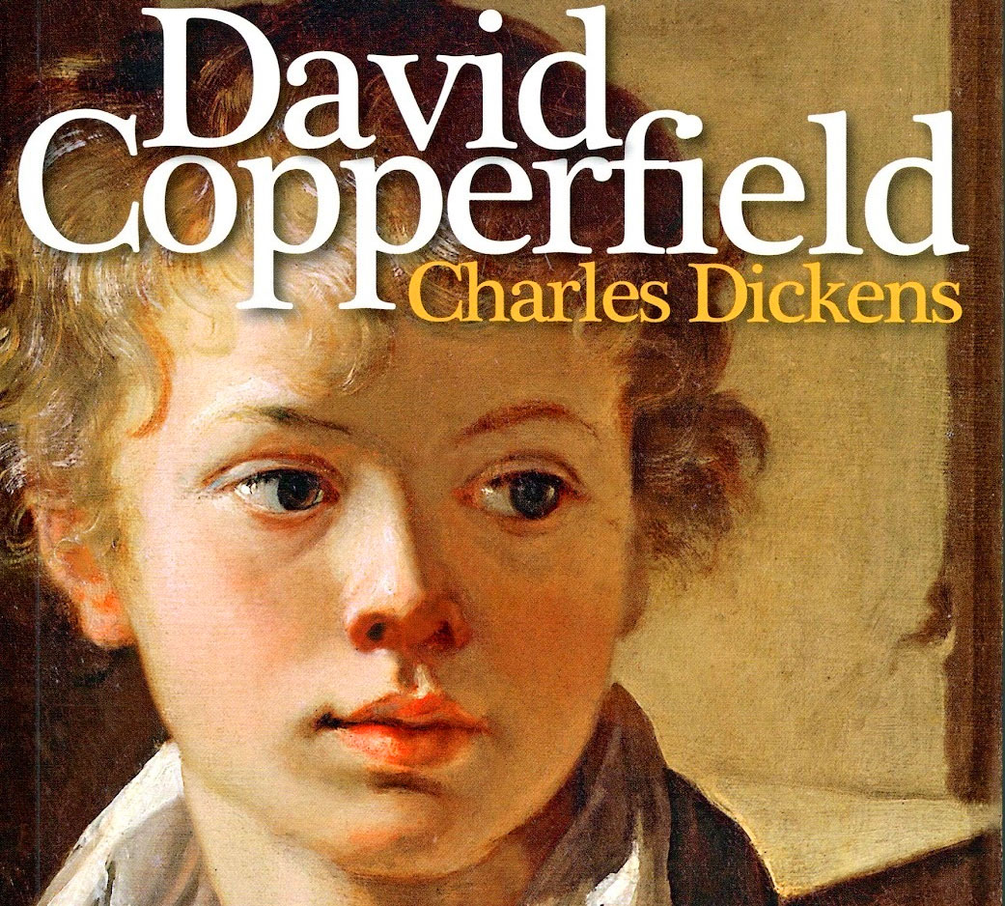
David Copperfield is the eighth novel by Charles Dickens. It was first published as a serial (a puntate, come una serie) in 1849–50, and as a book in 1850.
The novel features the character David Copperfield, and is written in the first person, as a description of his life, with his own adventures and the numerous friends and enemies he meets along his way. It is his journey of change and growth from infancy to maturity.
David Copperfield is an orphan who lost his father when he was still in swaddling clothes (in fasce). He spends his childhood with his mother and the housekeeper (governante) Peggotty. The mother, however, feels alone and with the great responsibility of raising (crescere) a child, so she decides to marry Mr. Murdstone when David was seven years old. The stepfather is a very strict person and he never misses an opportunity to beat (picchiarlo) and humiliate him. Due to David's childhood exuberance, the boy is sent to boarding school (collegio), an equally hostile environment but where he meets many friends including Steerforth, who will always stay with him.
Unfortunately, David's mother also dies because of the pressures undergone by her husband and Miss Jane and David find themselves alone in the world. His stepfather decides to send him to work in a factory in Blackfriars, where the boy is forced to live a very hard life. The boy decides to run away and takes refuge in Dover, where his aunt Betsey Trotwhood lives, who helps him settle down (a sistemarsi) with lawyer Wickfield and finish his studies.
Here David becomes the confidante (confidente) of the lawyer's daughter, sweet Agnes and lives his first love affairs (storie d’amore): first with the young Emily and then with Miss Dora, whom he marries a few years after finding a job. However, Dora dies from a miscarriage (aborto spontaneo) and David Copperfield finds the sweet Agnes as the only support. He discovers that he has a feeling for her and after some time the two get married, completing the family with four children.

Questo testo è da tradurre per venerdì prossimo. Inoltre, fate un riassunto, così da potermelo ripetere durante la video lezioni.
Have a nice day!

