III A Gioiosa Marea
Lingua Inglese
Prof. Margherita Sirna
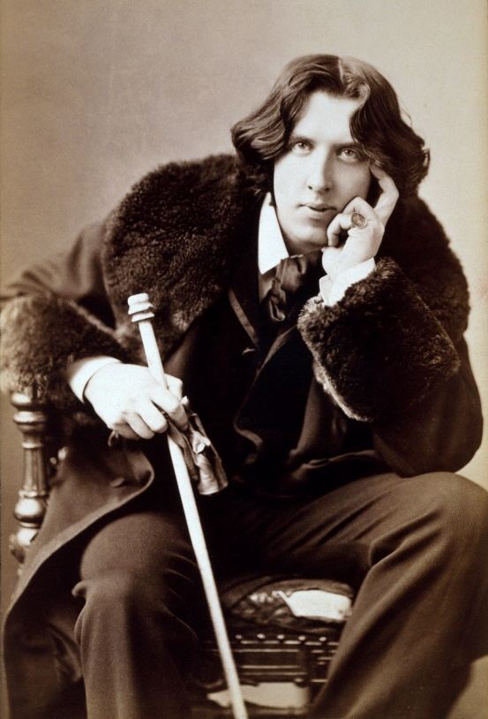
Oscar Wilde
Oscar Fingal O'Flahertie Wills Wilde (16 October 1854 – 30 November 1900) was an Irish poet and playwright. After writing in different forms throughout the 1880s, he became one of the most popular playwrights in London. He is best remembered for his epigrams and plays, his novel “The Picture of Dorian Gray”, and the circumstances of his criminal conviction for "gross indecency", imprisonment, and early death at age 46.
Wilde's parents were Anglo-Irish intellectuals in Dublin. A young Wilde learned to speak fluent French and German. He studied first at Trinity College Dublin, then at Oxford. After University, Wilde moved to London into fashionable cultural and social circles.
He published a book of poems, lectured in the United States and Canada on the new "English Renaissance in Art" and interior decoration, and then returned to London where he worked prolifically as a journalist. At the turn of the 1890s, he refined his ideas about the supremacy of art in a series of dialogues and essays, and incorporated themes of decadence, duplicity, and beauty into what would be his only novel, “The Picture of Dorian Gray” (1890).
But Wilde was also prosecuted by the Marquess of Queensberry for criminal libel. The Marquess was the father of Wilde's lover, Lord Alfred Douglas. The libel trial (processo) caused Wilde to drop his charges and led to his own arrest and trial for gross indecency with men. After two more trials he was convicted and sentenced to two years' hard labour, the maximum penalty, and was jailed from 1895 to 1897. During his last year in prison, he wrote “De Profundis”, a long letter which discusses his spiritual journey through his trials. On his release, he left immediately for France, never to return to Ireland or Britain. There he wrote his last work, “The Ballad of Reading Gaol” (1898), a long poem commemorating the harsh rhythms of prison life.

The Picture of Dorian Gray
The story begins with a man painting a picture of Gray. When Gray, who has a "face like ivory and rose leaves", sees his finished portrait, he breaks down. Distraught that his beauty will fade while the portrait stays beautiful, he inadvertently makes a Faustian bargain in which only the painted image grows old while he stays beautiful and young. For Wilde, the purpose of art would be to guide life as if beauty alone were its object. As Gray's portrait allows him to escape the corporeal ravages of his hedonism, Wilde sought to juxtapose the beauty he saw in art with daily life.
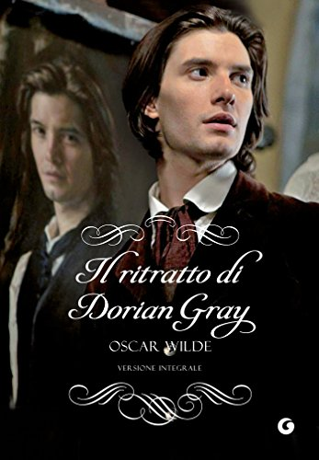
Per il prossimo mercoledì, fate la lettura, la traduzione e il riassunto scritto, che vi chiederò nella prossima lezione.
Have a nice day!

