III A Gioiosa Marea
Lingua Inglese
Prof. Margherita Sirna
Ciao ragazzi! Durante la videochiamata, leggeremo questo testo sulla Regina Elisabetta.

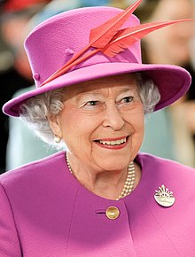

The Queen Elizabeth II
Elizabeth II (Elizabeth Alexandra Mary; born 21 April 1926) is Queen of the United Kingdom and the other Commonwealth realms.
Elizabeth was born in London, the first child of the Duke and Duchess of York, later King George VI and Queen Elizabeth, and she was educated privately at home. Her father ascended the throne on the abdication of his brother King Edward VIII in 1936. She began to undertake public duties during the Second World War, serving in the Auxiliary Territorial Service. In 1947, she married Philip, Duke of Edinburgh, a former prince of Greece and Denmark, with whom she has four children: Charles, Prince of Wales; Anne, Princess Royal; Prince Andrew, Duke of York; and Prince Edward, Earl of Wessex.
When her father died in February 1952, Elizabeth became head of the Commonwealth and queen regnant of seven independent Commonwealth countries: the United Kingdom, Canada, Australia, New Zealand, South Africa, Pakistan, and Ceylon.
She is the longest-lived and longest-reigning British monarch. She is the longest-serving female head of state in world history, and the world's oldest living monarch.
Elizabeth has occasionally faced republican sentiments and press criticism of the royal family, in particular after the breakdown of her children's marriages, and the death in 1997 of her former daughter-in-law Diana, Princess of Wales.
She has a deep sense of religious and civic duty. She is patron of over 600 organisations and charities. In the 1950s, as a young woman at the start of her reign, Elizabeth was depicted as a glamorous "fairytale Queen".[206] After the trauma of the Second World War, it was a time of hope, a period of progress and achievement heralding a "new Elizabethan age".

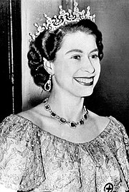

Per mercoledì 21 fate la traduzione di questo testo e il riassunto in inglese da ripetere poi a me oralmente.
Per venerdì 16, invece, giorno in cui ci rivedremo dopo le vacanze di Pasqua, fate i compiti di grammatica che vi avevo lasciato.
Inoltre, scrivete una pagina di diario, in inglese, nella quale parlate di come passate le giornate durante la quarantena.
“MY QUARANTINE DIARY”
Se volete, potete aggiungere cosa fate a Pasqua e pasquetta.
Preferirei che mi inviaste i compiti via email, così da poterli correggere e potervi rispondere via email. Vi scrivo la mia email su WhatsApp.
Have a nice day!
And happy Easter!

